**Capacitated Green Vehicle Routing Problem (MDGVRP)**

|  |  |  |
| --- | --- | --- |
| **Frank Acquaye**  Faculty of Computer Science, HSE  fakvey@edu.hse.ru | **Elie Wanko**  Faculty of Computer Science, HSE  evankopokhdi@edu.hse.ru | **Samira Nasrin**  Faculty of Computer Science, HSE  snasrin@edu.hse.ru |

**Abstract**

In this project, we investigate a Capacitated Green Vehicle Routing Problem (CGVRP). Our proposed solution is a variant of the Capacitated Green Vehicle Routing Problem (CGVRP), here we are considering a situation where we have only one depot. Eventually, this can be extended to a multi-depot scenario. We consider a situation in which distributors who are used to conventionally powered vehicles are faced with the daunting task of managing a fleet of both traditional fuelled vehicles and alternatively fuelled vehicles. Alternative Fuel-powered vehicles (AFVs) start from the existing warehouses, serve customers and, at the end of the day, return to the original warehouses. The limited travel distance before refuelling of AFVs forces them to function within a limited range especially if the distributor does not have the means of providing multiple refuelling stations.

**Keywords:** vehicle routing problem; alternative fuel-powered vehicles; renewable energy; CGVRP, CVRP, VRP, TSP.

1. **Introduction**

**Renewable** **energy** demand increased by about 1.5% in Q1 2020, lifted by the additional output of new wind and solar projects that were completed over the past year. In most cases, renewables receive priority in the grid and are not asked to adjust their output to match demand, insulating them from the impacts of lower electricity demand. As a result, the share of renewables in the electricity generation mix rose considerably, with record-high hourly shares of variable renewables in Belgium, Italy, Germany, Hungary, and eastern parts of the US.

According to the International Energy Agency (IEA) study, 23% of global emissions are produced by the transport industry, with almost 75% of the emissions created by the road system. These statistics show a growing need to reduce the CO2 emissions generated by the road sector. Green Logistics emphasises the sustainability of logistics operations to reduce pollution in the road transport sector. Green logistics advocate the adoption of clean energy, such as electricity and hydrogen, to reduce pollution. The problem with the configuration of the green vehicle routing scheme is named the Green Vehicle Routing Problem (GVRP).

More and more distributors are faced with the daunting task of moving towards green energy in all aspects of operations. This often involves switching distribution vehicles to vehicles that consume alternate fuel. The challenge with alternate fuel however is the limited travel distance before the need for refuelling. Hence these distributors often have vehicles that use traditional fuel and vehicles that use alternate fuel. Our goal is therefore to produce an optimisation algorithm that maximizes the distribution paths of green fuelled vehicles and minimizes the distribution paths of traditional vehicles all this while ensuring that the total demand for services/products is met.

This paper is organised as follows. In Section 2, a related literature review is presented. Section 3 introduces the definition and formulation of our CGVRP. Section 4 presents the algorithms designed for solving CGVRP. Results are presented in Section 5 and are followed by the conclusion in Section 6.

1. **Literature Review**

In recent years, GVRP has received much attention from researchers and academics since people are becoming increasingly aware of environmental concerns**.** According to a comprehensive literature survey on the GVRP in [2], there are three categories of GVRP, namely Pollution Routing Problem (PRP), Green-VRP (G-VRP) and VRP in reverse logistics. Although these categories focus on economic costs and environment costs simultaneously, the PRP is focused on minimizing the fuel consumption, and the G-VRP is focused on using AFVs instead of conventional vehicles. Therefore, the objective function of PRP is the minimization of the total GHG (Green house gas), and the objective of G-VRP is the minimization of the total travel distance of all AFVs.

1. **Problem Description and Formulation**

A standard CGVRP can be described as finding routes with the least distance from a depot to a set of customers. Each customer is visited by the vehicle fleet only once, and the demand of the customer is satisfied after each visit. A vehicle starts from a depot, serves customers one-by-one, and, finally, returns to its originally assigned depot. During the service process, when the remaining fuel of a vehicle is not able to satisfy the demand of the next customer, the vehicle can return to the depot for refuelling or recharging.

With our variant of the CGVRP the distributor has a set of Green Vehicles and a set of Conventional Vehicles. The challenge however is the limited travel distance of Green Vehicles before needing to recharge.

Although in conventional literature Green Vehicles are known as AFV’s we shall use Green Vehicles(GV) for this study. Also we shall represent our Conventional Vehicles as (CV).

* 1. **Mathematical Formulation**

$n$**=** the number of clients

$N$ = set of clients, with $N=\{1,2,...,n\}$

$V$ = set of vetices (or nodes), with $V=\{0\}∪N$

$A$ = set of arcs, with $A=\{(i,j)∈V^{2}:i≠j\}$

$c_{ij}$ = cost of travel over arc $(i,j)∈A$

$Q$ = the vehicle capacity

$q_{i}$ = the amount that has to be delivered to customer $i∈N$

$GVs$ = set of Green Vehicles, with $GVs=\{1,2,...,n\}$

$CVs$ = set of Green Vehicles, with $CVs=\{1,2,...,n\}$

Our goal is to:

*For Each GV in GVs:*

*maximize route used*

*For Each CV in CVs:*

*minimize route used*

*Such that Total Demand is always met.*

1. **Solution of CGVRP**

In this section, we proposed a method designed to solve CGVRP:

* ***Step 1:***  *We assume the base case for the* ***CGVRP*** *in each instance, which is a single vehicle, Upon considering this as a single vehicle, it becomes a* ***TSP.***
* ***Step 2:*** *We consider the locations of our depot in relation with our customers as a*
* ***Step 3:*** *Define a maximum travel distance for* ***GV***  *before refuelling*
* ***Step 4:*** *Set* ***threshold*** *to maximum travel distance/2*
* ***Step 5:***  *Naively solve the* ***TSP*** *problem for* ***GV*** *with the notion that always branch on smallest route provided total travel distance is less than* ***threshold***
* ***Step 6:***  *Nodes obtained from* ***Step 6*** *are exempted from the primary graph, thereby generating two separate graphs. One for* ***GV***  *and the other for* ***CV***
* ***Step 7:*** *Graphs obtained from step 6 are solved considering them as* ***CVRP ,*** *using the formula below: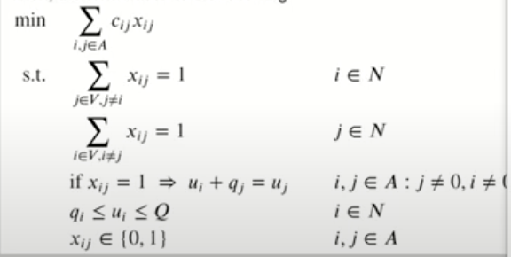*

Figure 1: CVRP solution

1. **Results of Our Approach**

Random Data was generated for the initial setup our problem.

We tested our algorithm with 20 clients and the resulting setup is shown in Figure 2. The red dot depicts the depot and the blue dots depict the customers.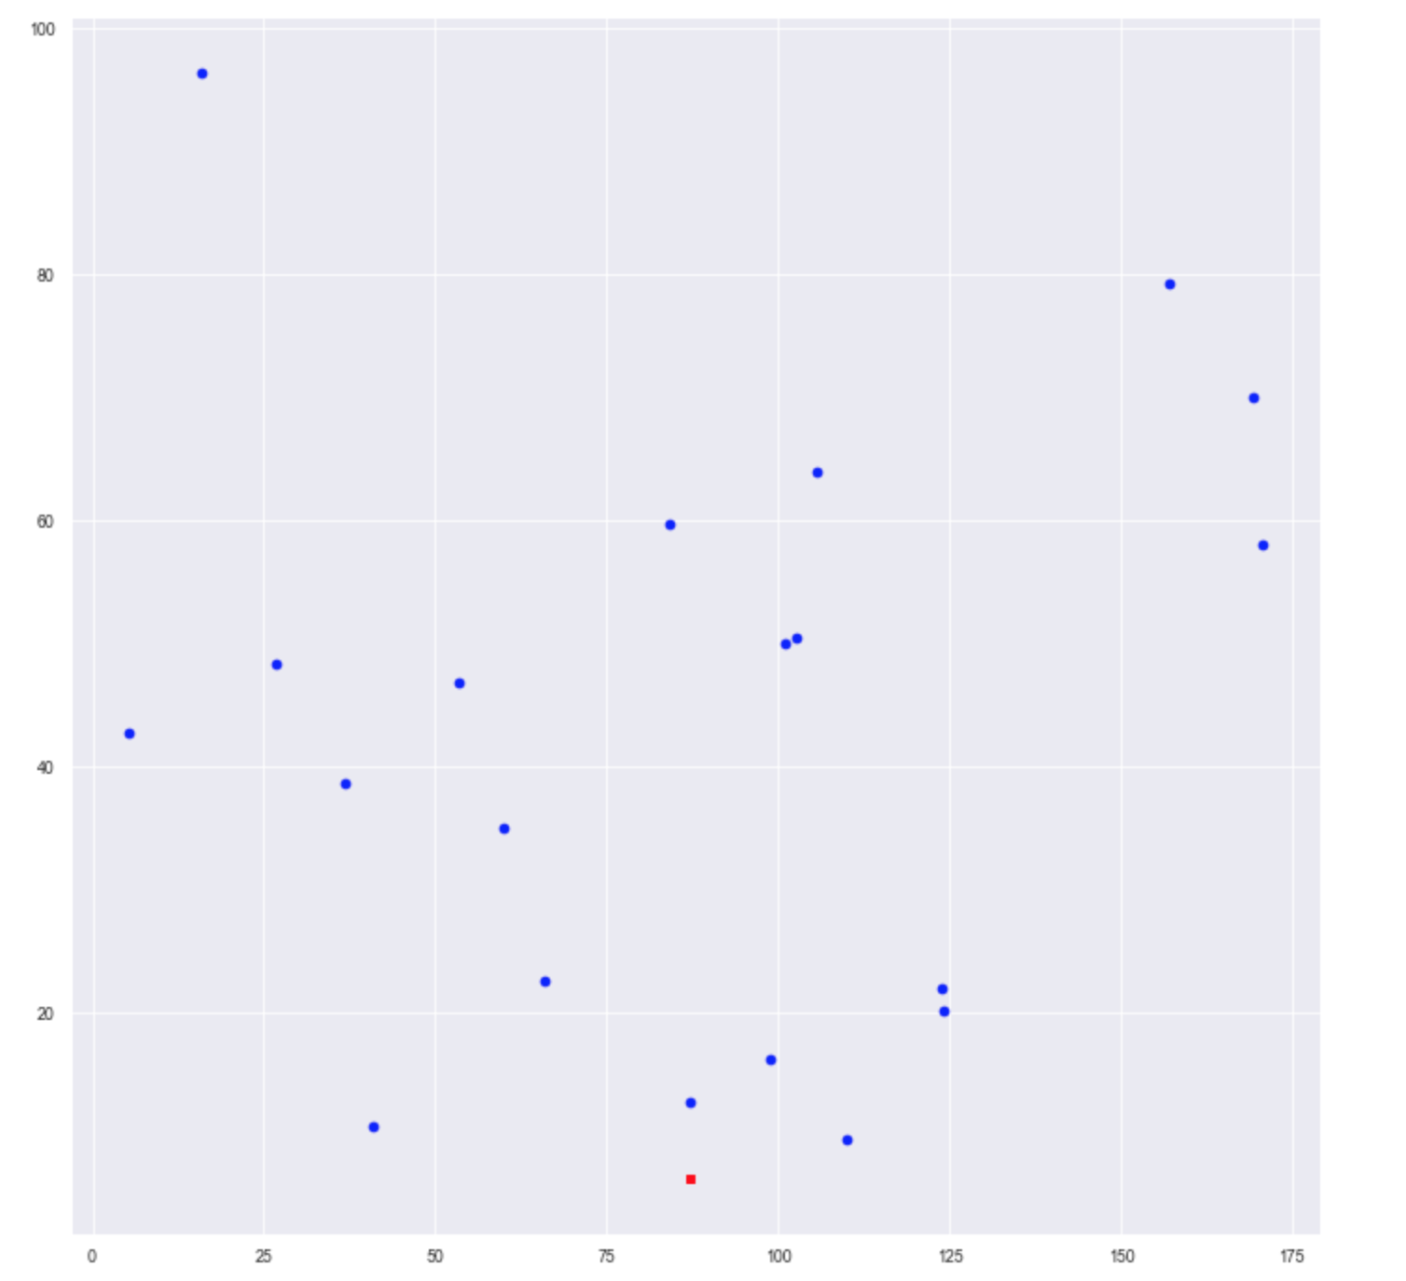

Figure 2: Location of depot and customers (red dot depicts the depot and blue dot depicts customers)

After running our algorithm two seperate routes were obtained, one for **CV** one for **GV.**

The **CV** solution is presented on the left and the **GV** solution on the right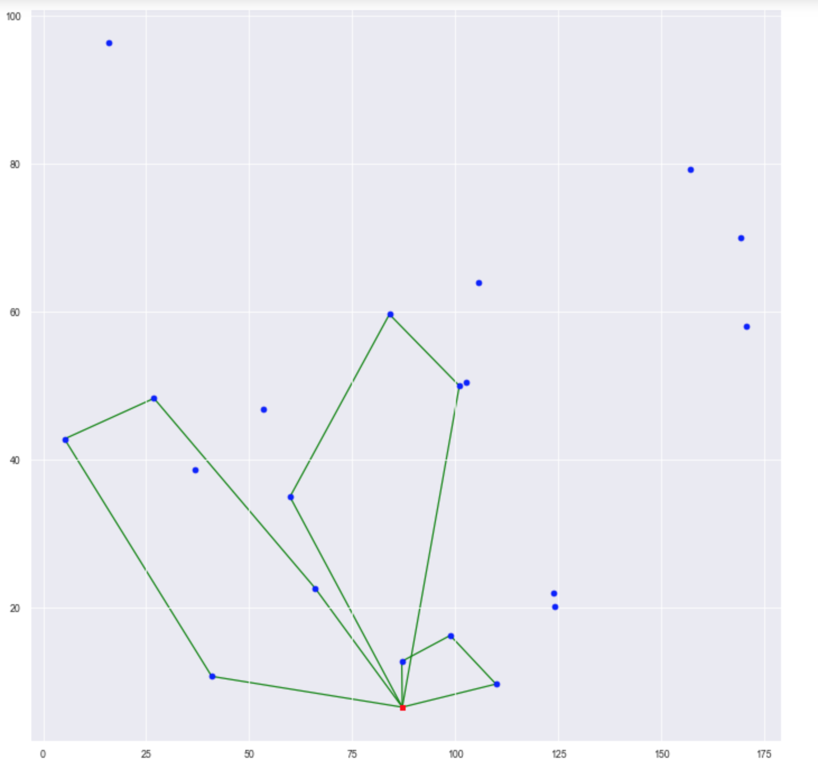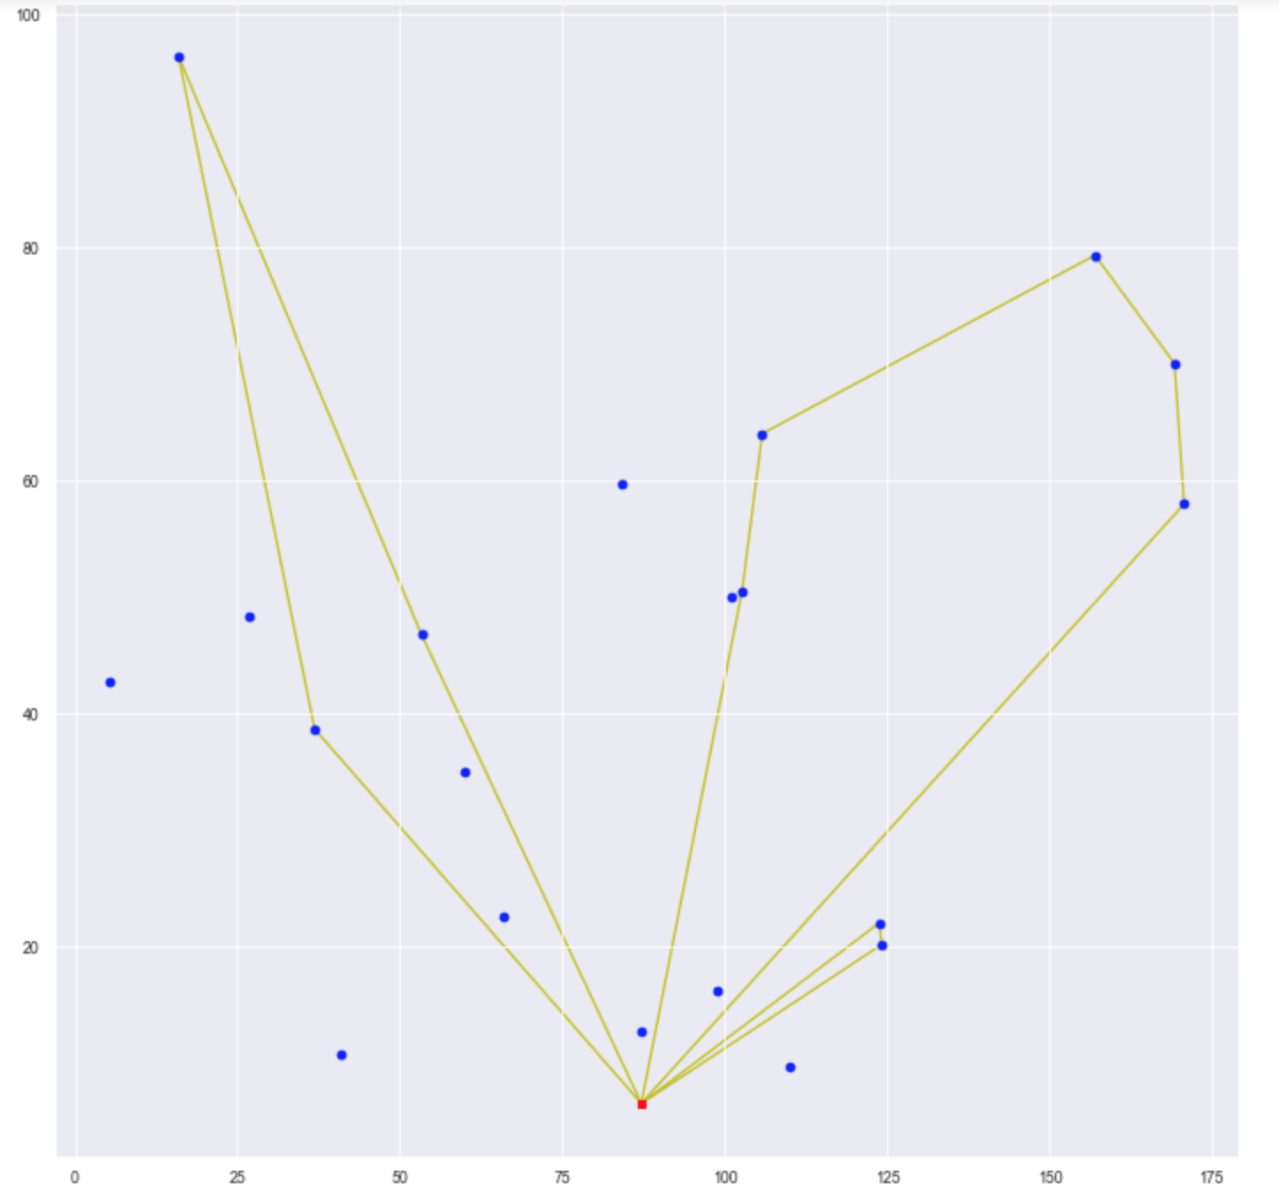

1. **Conclusion**

With our algorithm distributors can effectively manage and route both Green Vehicles and Conventional Vehicles.

For further investigations we will like to check the complexity of our algorithm and how it performs in relation with larger and larger data sets. Perhaps better graph partitioning algorithms could be used. Also this solution may be extended to the Multi-Fleet Vehicle Routing Problem as well as the Muti-Depot Vehicle Routing Problem.

**Code Implementation:**

<https://github.com/acquayefrank/aql_project>

**References**:

1. Erdo˘gan, S.; Miller-Hooks, E. A green vehicle routing problem. Transp. Res. Part E Logist. Transp. Rev. **2012**, 48, 100–114. [CrossRef]
2. Lin, C.; Choy, K.L.; Ho, G.T.; Chung, S.H.; Lam, H. Survey of green vehicle routing problem: Past and future trends. Expert Syst. Appl. **2014**, 41, 1118–1138. [CrossRef]
3. First quarter of 2020 - compared with first quarter of 2019 [CrossRef]
4. Kaabachi, I.; Jriji, D.; Krichen, S. An improved ant colony optimization for green multi-depot vehicle routing problem with time windows. In Proceedings of the 2017 18th IEEE/ACIS International Conference on Software Engineering, Artificial Intelligence, Networking and Parallel/Distributed Computing (SNPD) IEEE, Kanazawa, Japan, 26–28 June 2017; pp. 339–344.
5. Jabir, E.; Panicker, V.V.; Sridharan, R. Design and development of a hybrid ant colony-variable neighbourhood search algorithm for a multi-depot green vehicle routing problem. Transp. Res. Part D Transp. Environ. **2017**, 57, 422–457. [CrossRef]
6. Li, J.;Wang, R.; Li, T.; Lu, Z.; Pardalos, P.M. Benefit analysis of shared depot resources for multi-depot vehicle routing problem with fuel consumption. Transp. Res. Part D Transp. Environ. **2018**, 59, 417–432. [CrossRef]
7. Wang, Y.; Assogba, K.; Fan, J.; Xu, M.; Liu, Y.;Wang, H. Multi-depot green vehicle routing problem with shared transportation resource: Integration of time-dependent speed and piecewise penalty cost. J. Clean. Prod. **2019**, 232, 12–29. [CrossRef]
8. Zhang, S., Gajpal, Y. & Appadoo, S.S. A meta-heuristic for capacitated green vehicle routing problem. *Ann Oper Res* **269,**753–771 (2018). [[CrossRef](https://doi.org/10.1007/s10479-017-2567-3)]